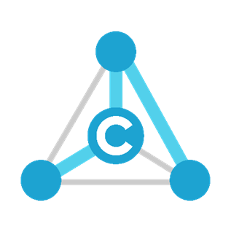

C-Labs™ User Guide

095 – Cloud Service Plugin

Revision Number 1
March 3, 2017

C-Labs • www.c-labs.com • info@c-labs.com

US & Canada  1-844-C-LABS-44 | Worldwide  +1(425) 999-3295

Table of Contents
Chapter 1: Introduction to Cloud Service Plugin 3
About the C-Labs™ Factory-Relay™ 3
Chapter 2: Installing Plugins 4
What You Will Need 4
Login to Administrator Account 4
Upload Plugin Installation Packages 5
Completing Plugin Installation 6
Chapter 3: Configuring the Cloud Service Plugin 8
Creating Cloud Connections 8
Incoming Data Configuration: Receive Thing List 10
Outgoing Data Configuration: Sender Thing List 12
Appendix A: Factory-Relay Navigation Icons 15

Chapter 1: Introduction to Cloud Service Plugin

The C-Labs Cloud Service plugin extends the C-Labs™ Factory-Relay™ by enabling data exchange between Factory-Relay and cloud messaging services. Supported services as of this writing include:
- Microsoft Azure Event Hubs – send or receive event stream.
- Http Post – Send messages using HTTP Post
- MQTT – Receive message sent using the MQ Telemetry Transport protocol
- Native Factory-Relay Message Service – send messages between Factory-Relay nodes.

To use these services, the C-Labs Cloud Service plugin must be installed. Chapter 2 in this document describes installing plugins into the C-Labs Factory-Relay.

Chapter 3 describes how to configure the Cloud Service plugin.

About the C-Labs™ Factory-Relay™
C-Labs created the Factory-Relay to provide remote and mobile access to industrial production equipment in a secure, efficient, extensible manner. In the interest of operational efficiency and reduced complexity, industrial systems are often configured with data security features disabled or turned off. With its built-in, IT-friend data security settings, Factory-Relay can seamlessly connect production systems to office systems without compromising factory operation or IT data security requirements.

Chapter 2: Installing Plugins
The C-Labs Factory-Relay can be extended using plugins. This chapter describes how to install plugins to Factory-Relay.

What You Will Need
Before you begin, make sure you have the following:
- Login Credentials – To install plugins to Factory-Relay, you need administrative login credentials.
- Plugin Installation Packages – Plugin installation packages are single files of the type “CDEX”. For example, here are two plugin installation packages. One is for the OPC UA Client, and the other is for Cloud Service:
  - OPC/UA Client plugin:
CDMyOPCUAClient-cdeOPCUaClient V3.225.CDEX
  - Cloud Service plugin:
CDMyCloudServices-cdeMyCloudService v3.225.CDEX

Login to Administrator Account
- Start by logging into a Factory-Relay system with an administrator login account. An administrator home page, like the following, appears:
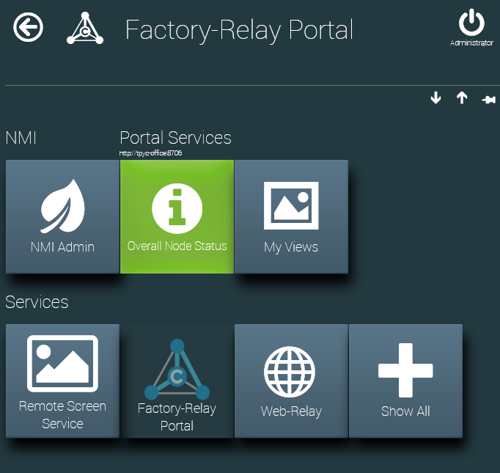
Factory-Relay administrator home page
Click
Factory-Relay Portal

Upload Plugin Installation Packages
- Click on the Factory-Relay Portal button. The dashboard for the Factory-Relay portal appears:
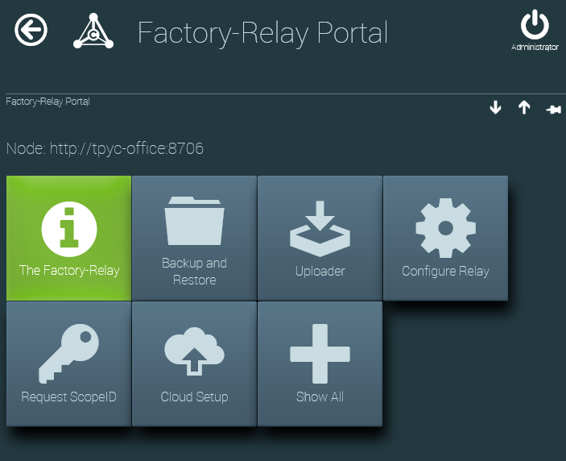
Factory-Relay Portal Dashboard
Click
Uploader
- On the Factory-Relay Portal dashboard, click the Uploader button. The File Uploader page appears:
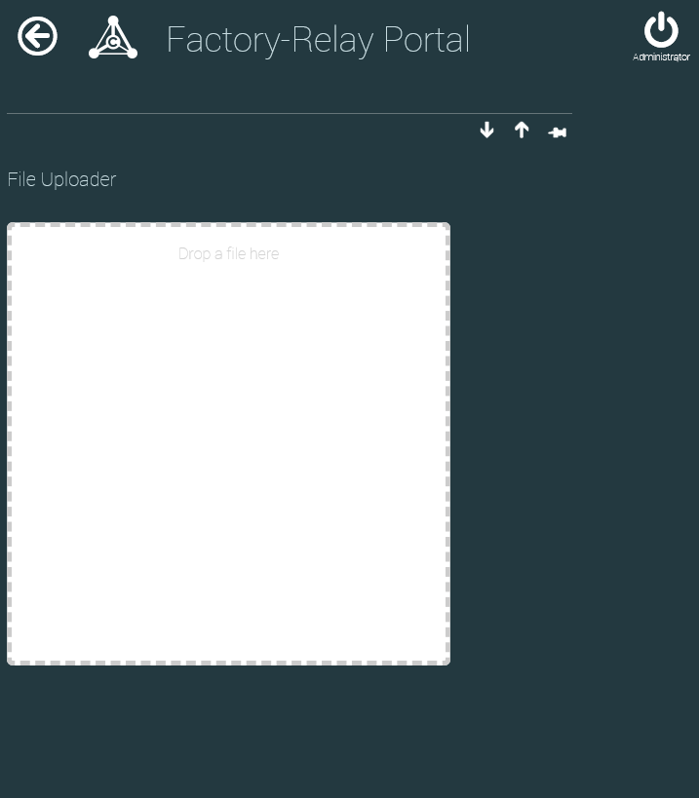
File Uploader Page
- Open the Windows File Explorer. Drag installation package files into the File Uploader.
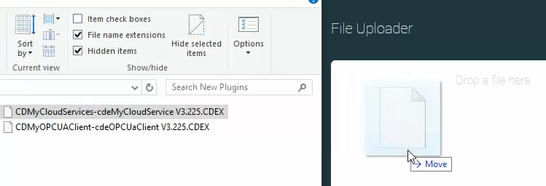
- After each file is uploaded, you see a brief message like the following appears in the lower part of the uploader page:
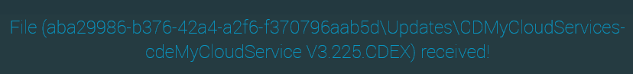

Completing Plugin Installation
- To install the plugin, navigate to the Factory-Relay home page.
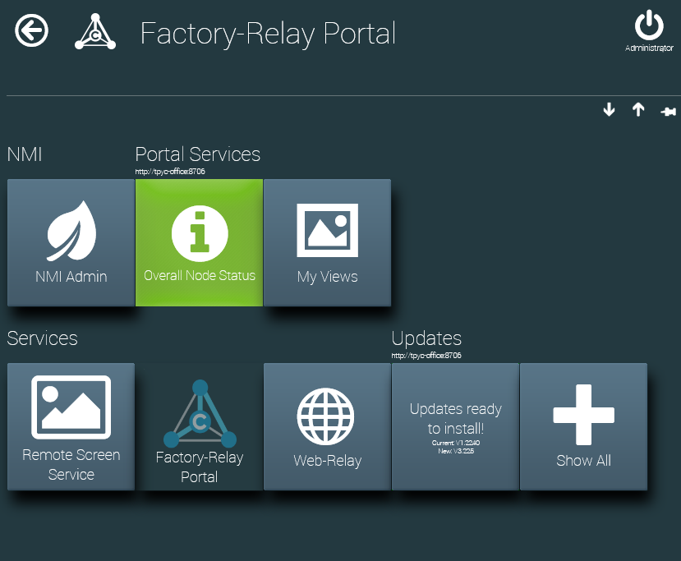
The administrator home page ready to install a plugin.
Click
Updates ready to install!!
- A new button appears on the page that says Updates ready to install!! Click this button.
- You are asked for confirmation. Click the Yes button.
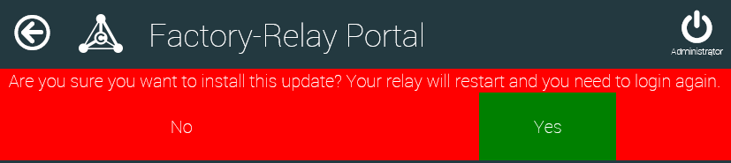
- After a plugin is installed, you see a message like the following:
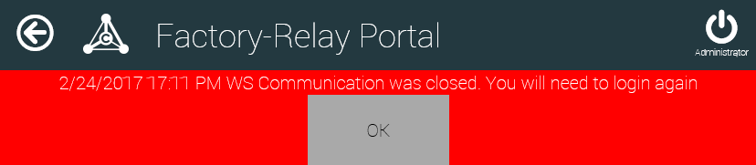
Click OK
- Click the OK button.
- Login to see the new plugin.
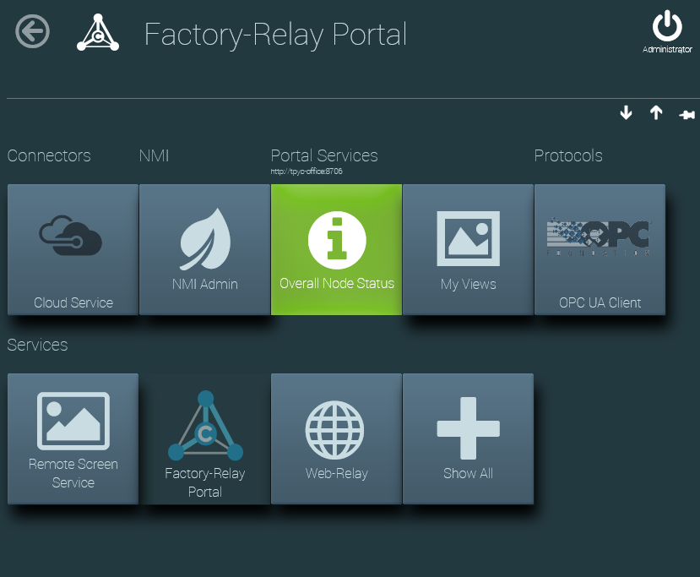
New!

Chapter 3: Configuring the Cloud Service Plugin
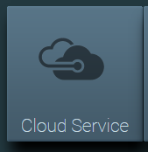
Cloud Service icon, from Factory-Relay admin home page
To configure the Cloud Service plugin, click the Cloud Service icon on the home page of a Factory-Relay admin. (If the icon is missing, install the Cloud Service plugin. For details, contact C-Labs.)

Creating Cloud Connections
Start the process of configuring the cloud service connector by creating a cloud connection.
- From the Cloud Service dashboard, click the Cloud Connections button.
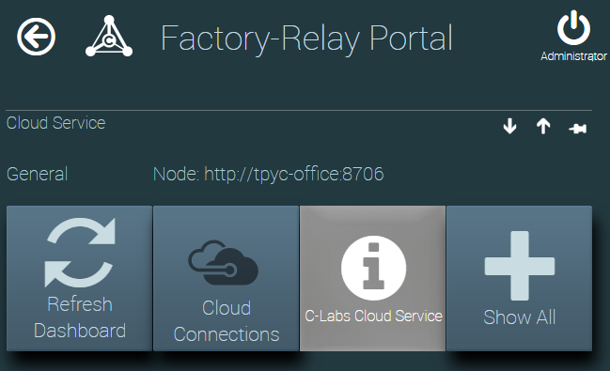
The Dashboard for the Cloud Service Plugin
Click
Cloud Connections
- You are shown a list of available cloud connections (which might, in fact, be empty). To create a new connection, click Add a Connection.
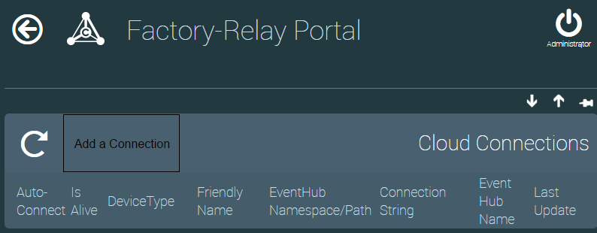
An empty list of cloud connections
Click
Add a Connection
- Input fields are created to accept details about the new connection. Enter connection details.
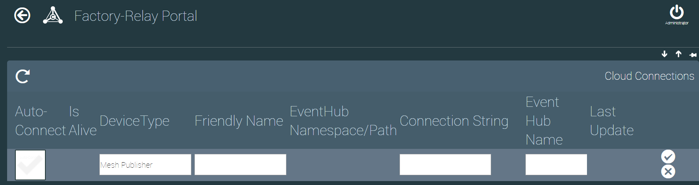
New connection input fields
Input field descriptions are in the following table. When done, click the () icon to save.
Column Title | Description
Auto Connect | When checked, a connection is created at system restart.
Is Alive | Indicator for whether a connection to the cloud service is currently open.
Device Type | Set the kind of connection. As of this writing, three sending and two receiving connection types are supported:  -- Receiver types: Azure Receiver, MQTT Receiver  -- Sender types: Azure Sender, Http Sender, Mesh Publisher
Friendly Name | A name to help human users remember the significance of a connection.
EventHub Namespace / Path | Addressing details used to help establish the connection.
Connection String | Server location and user credential details.
Event Hub Name | Azure connections use the event hub name to identify the specific event stream to access.
Last Update | Date when settings were last changed.
Here is a cloud connection list with two items defined: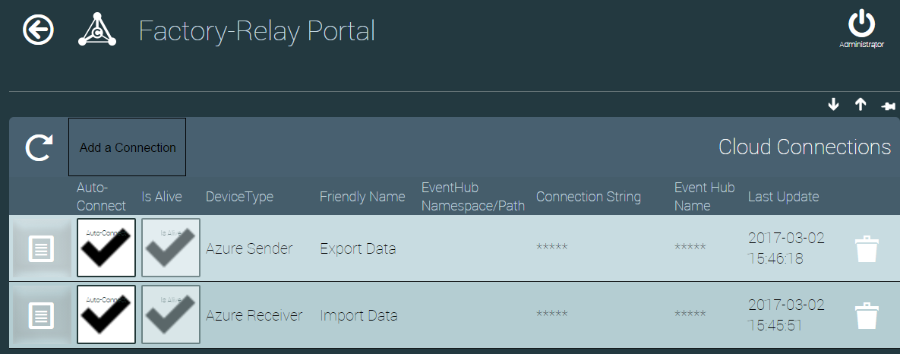Two cloud connections – one to send and the other to receive
Click to configure
- To configure a connection, click the properties icon ().
The next configuration step is identifying what to transfer. For this, the connection type is important. For an incoming cloud connection, a Receive Thing List identifies what to transfer. When outgoing cloud connections, a Send Thing List identifies what to transfer. The next two sections cover these two types of configuration.
Note: When Factory-Relay connects an incoming data stream to an outgoing data stream, you must first create the incoming connection. Outgoing connections require the “thing” for its data source, which in this case is the incoming data stream.

Incoming Data Configuration: Receive Thing List
Here is the configuration page when receiving incoming data.
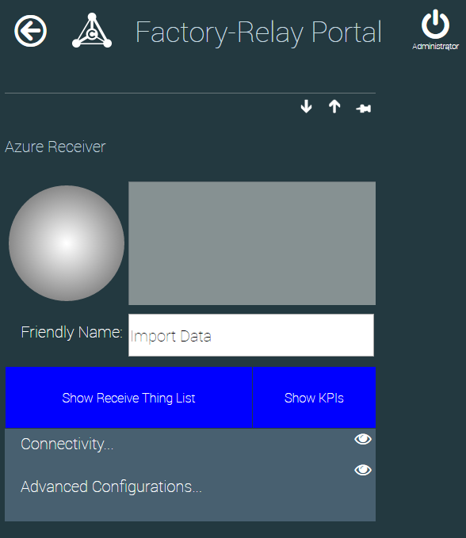
Click to configure incoming data stream
- Click the Show Receive Thing List button to configure incoming data.
- The Receiver Things to Connect configuration page appears. Click the Add new Thing button to add items to this list.
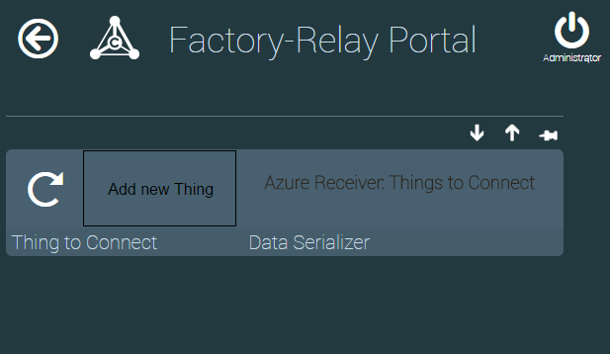
Click to create a new entry
- An empty set of data entry fields is displayed, ready for input.
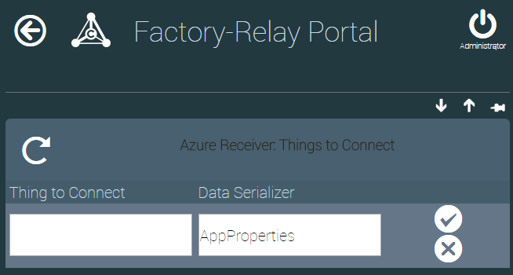
The Receive Things List, ready for a new item
Click to save
The Receive Things List connects two things, as detailed in this table:
Column Title | Description
Thing to Connect | Where to send incoming data. This could be any “thing” within Factory-Relay. To buffer large amounts of data, consider using a MemoryThing from the C-Labs Virtual Things plugin.
Data Serializer | Select the data serializer based on the incoming data format. Choices include:  - AppProperties  - Axoom IoT Manager  - CSV  - JSON OPC Properties  - JSON Objects  - JSON Objects Rooted  - JSON Properties

Outgoing Data Configuration: Sender Thing List
Here is the configuration page when sending data out to a cloud service:
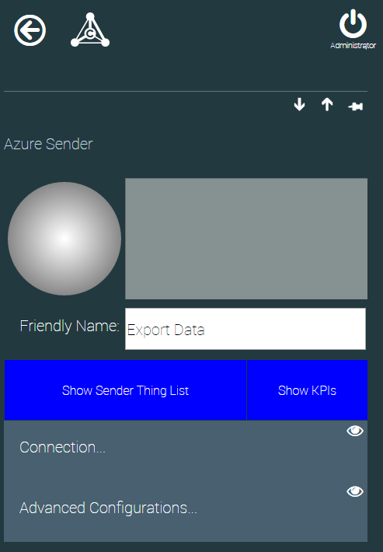
Click to configure outgoing data stream
- Click the Show Sender Thing List button to configure the outgoing data stream.
- The Sender Things to Publish page appears. Click the Add new Thing button to add to this list.
Click to create a new entry
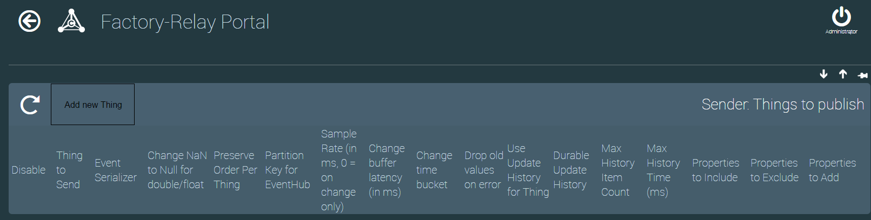
Click to save
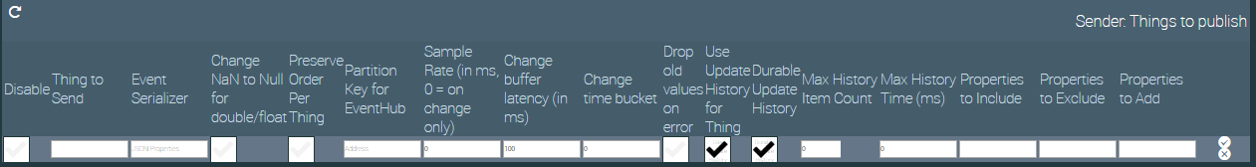
The Sender Things to Publish list contains seventeen columns, as described in the following table. When done, click the () icon to save.
Column Title | Description
Disable | When checked, prevents data from being sent.
Thing to Send | The Factory-Relay thing that provides the data to send.
Event Serializer | The format to use for sending the data. Choices include:  - AppProperties  - Axoom IoT Manager  - CSV  - JSON OPC Properties  - JSON Objects  - JSON Objects Rooted  - JSON Properties
Change NaN to Null for double / float | Whether to handle floating point errors (NaN = Not a Number) by setting to null or not.
Preserve Order Per Thing | Enforce FIFO (first-in first out) operation, possibly at the expense of overall system performance.
Partition Key for EventHub | Identifies how to organize and group outgoing data. Azure Event Hub only preserves order of event within a partition. Valid values include:  - None – allow Microsoft Azure to establish partitions. Best performance, but events will be randomly spread over the available partitions, with no order guarantee.  - Address – Organize by Address of the thing. This is a context-specific value which could be empty, or it could be a network URL or IP address. With the OPC / UA client, this is the OPC UA Server address.  - ThingID – Organize by the Factory-Relay thing identifier, which is a GUID and guaranteed to always be defined and always be unique.  - Fixed – Currently not used.
Sample Rate | Limits how often (in milliseconds) data gets read from the data source. When sample rate is zero, data gets sent immediately on receipt of a change notification. Ignored when using the native historian service.
Change Buffer Latency | The time to wait before declaring a time bucket as completed (in milliseconds). When set to zero, updates are sent on change. Ignored when using the native historian service.
Change Time Bucket | The time interval over which to aggregate events. The last event in a time interval is sent. When set to zero, only events with the exact same timestamp are aggregated.
Drop Old Values on Error | How to recover when disconnected from the cloud service. Default is to send all buffered values. When this flag is set, only the last event gets sent to the cloud service.
Use Update History for Thing | Whether to use the C-Labs native historian service to buffer changes (recommended).
Durable Update History | Whether to keep history across restarts of Factory-Relay.
Max History Item Count | The maximum number of events to keep in history. A value of 0 means there is no limit.
Max History Time | The maximum age, in milliseconds, to store buffered values before dropping them.
Properties to Include | A comma-delimited list of thing properties to include in the data sent to the cloud
Properties to Exclude | A comma-delimited list of thing properties to exclude from sending to the cloud.
Properties to Add | A comma-delimited list of static name-value pairs to include in the data stream (e.g. “MachineId=12345,Location=Building 3”.) The delimiter between name-value pairs is a comma.

Appendix A: Factory-Relay Navigation Icons
To help navigate the Machine Monitor configuration pages, we start with a summary of the navigation icons which are used on these configuration pages. The icons are summarized in the following table:
Icon | Name | Comments
 | Home | Navigate to main dashboard
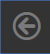 | Back | Use instead of the browser’s built-in back button.
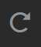 | Refresh | Use instead of the browser’s built-in refresh button.
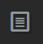 | Properties | Click to view properties
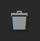 | Trash Can | Delete an item
 | Show More | Click to view expanded settings
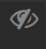 | Show Less | Click to hide expanded settings

